# **30. TCP and UDP (Layer 4 Protocols)**

## **Basics of Layer 4**

* **Provides transparent transfer of data between end hosts** (Host-to-Host communication).  
   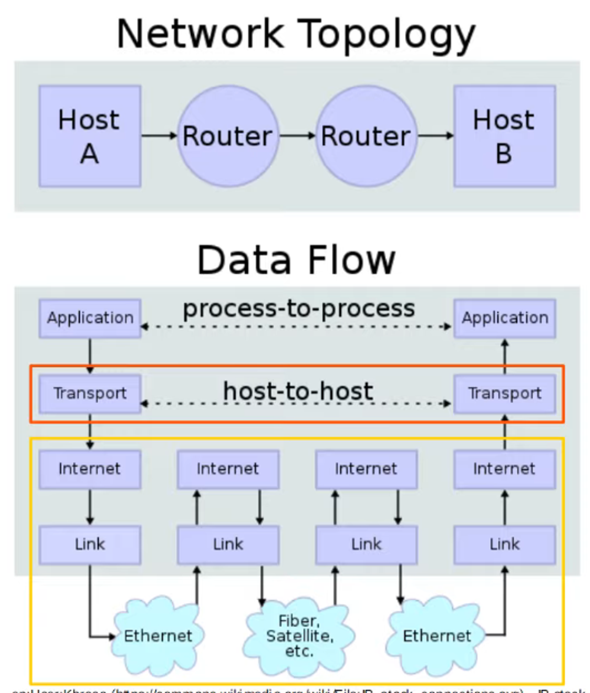
* **Provides (or doesn’t provide) various services to applications**:  
  + Reliable data transfer
  + Error recovery
  + Data sequencing
  + Flow control
* **Provides Layer 4 Addressing (Port Numbers)**:  
  + Identifies the application-layer protocol.
  + Provides session multiplexing (NOT physical interfaces/ports on network devices).

## **What is a Session?**

* A session is an **exchange of data between two or more communicating devices**.  
   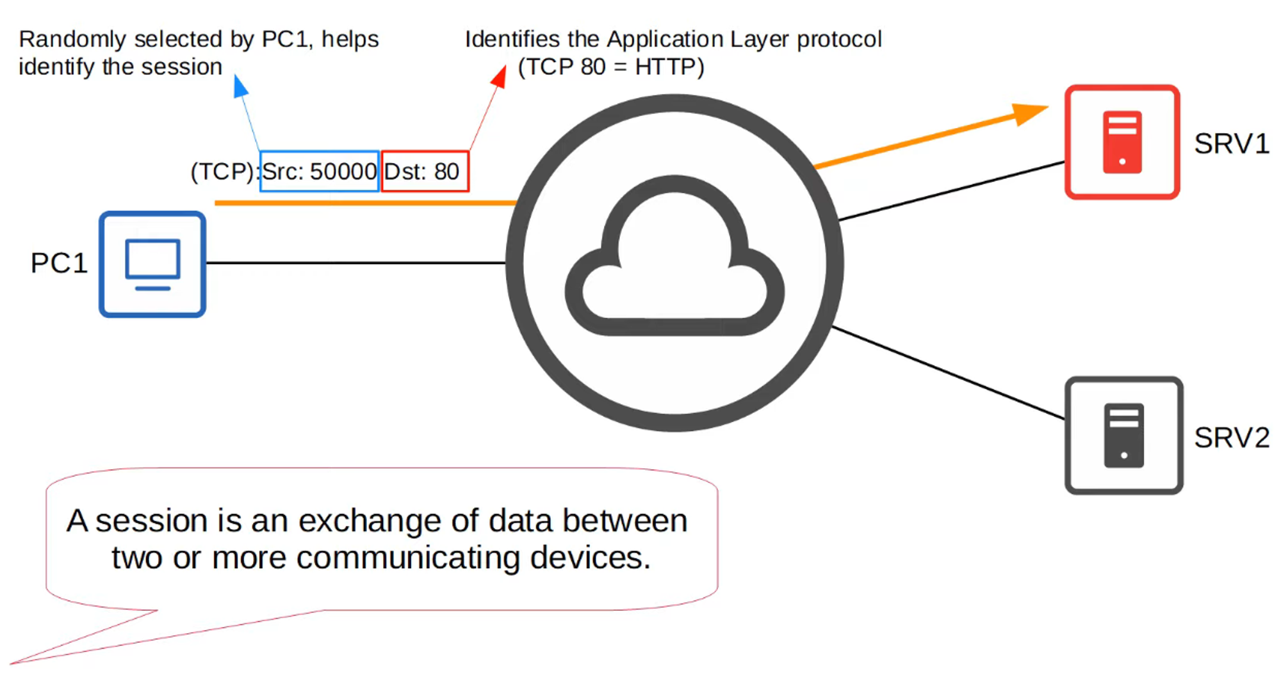

### **Port Number Ranges (Designated by IANA):**

* **Well-Known Ports**: 0–1023
* **Registered Ports**: 1024–49151
* **Ephemeral/Private/Dynamic Ports**: 49152–65535  
   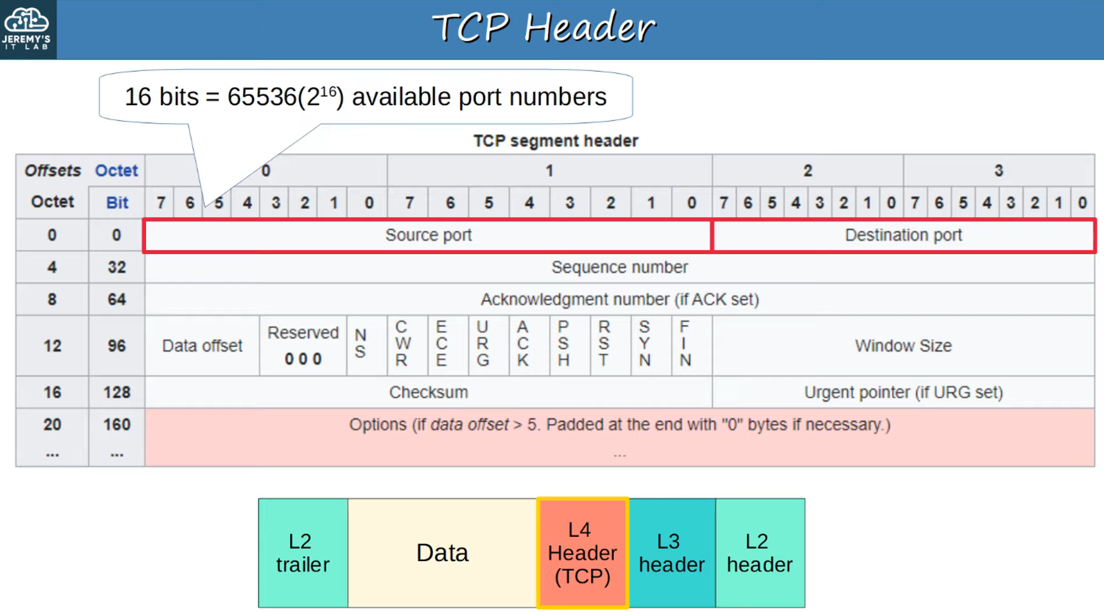

## **TCP (Transmission Control Protocol)**

* **Connection-Oriented Protocol**:  
  + Hosts establish a connection before data exchange begins.  
     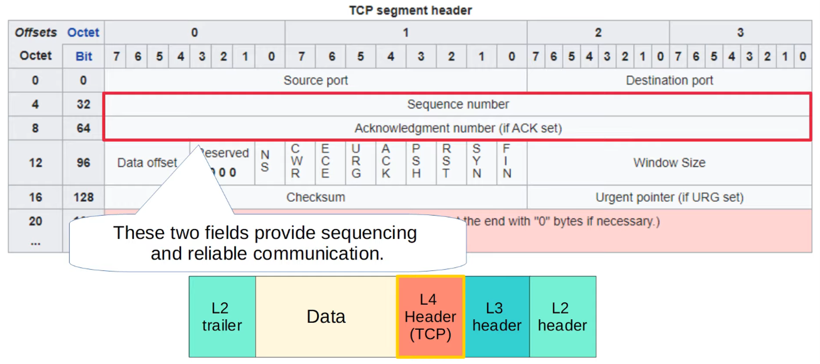
  + **Connection Establishment**:  
     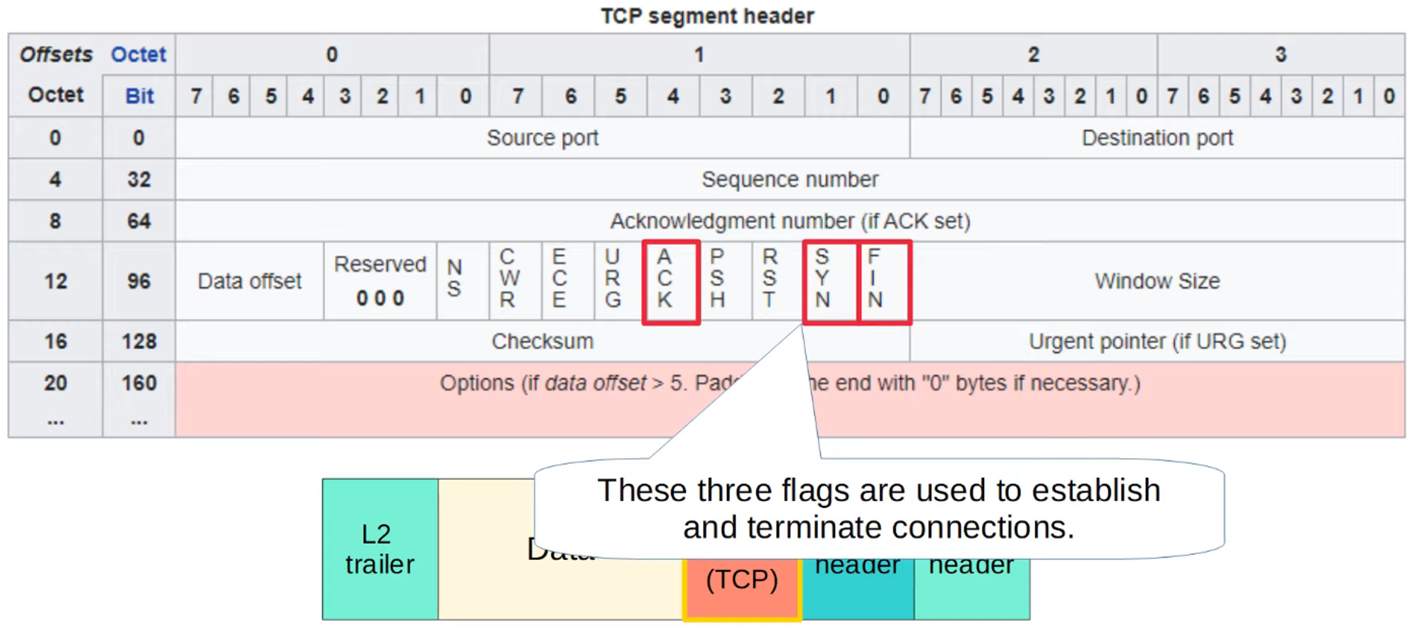  
     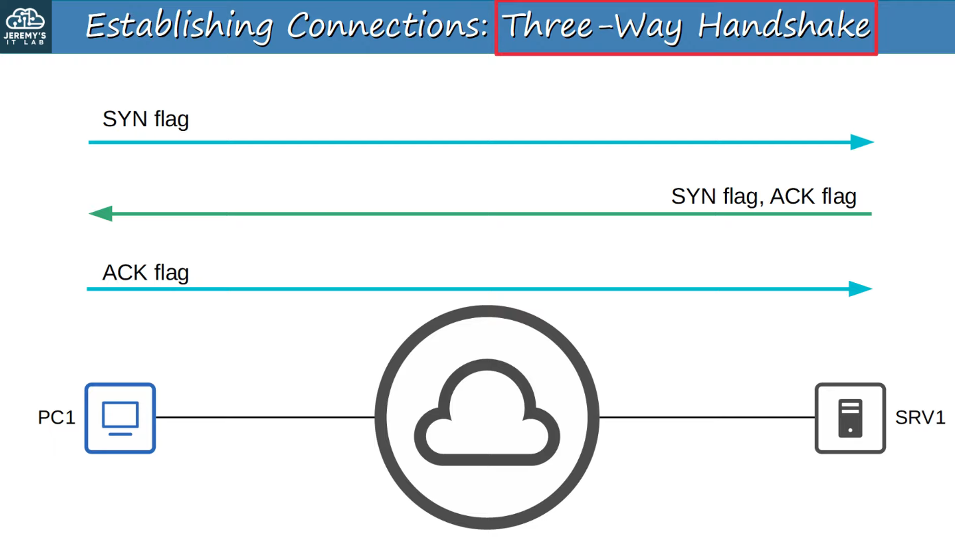
  + **Connection Termination**:  
     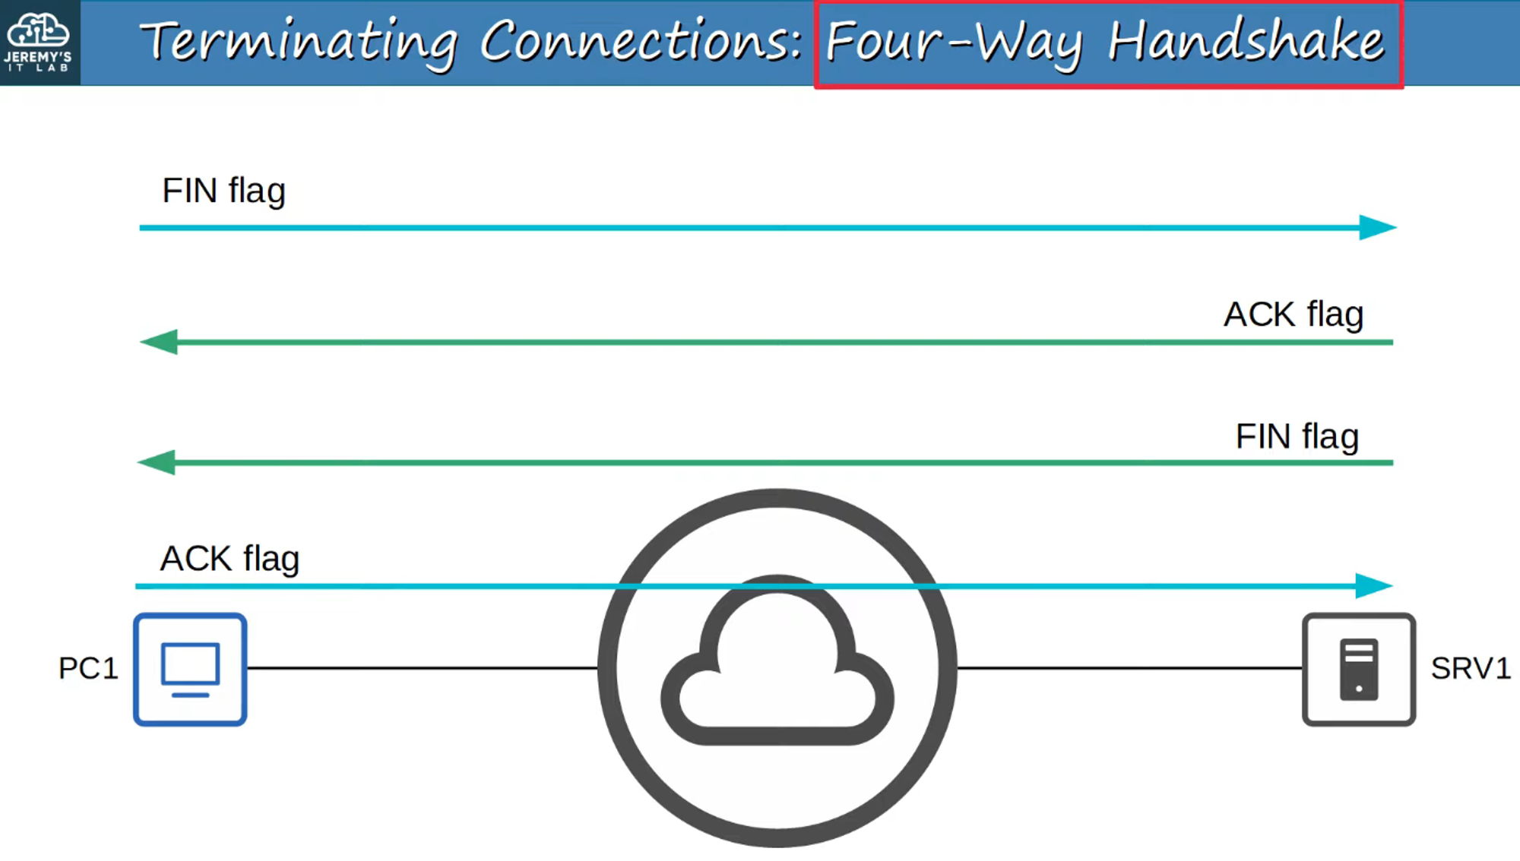
* **Reliable Communication**:  
  + Destination host must acknowledge receipt of each TCP segment.
  + Unacknowledged segments are retransmitted.  
     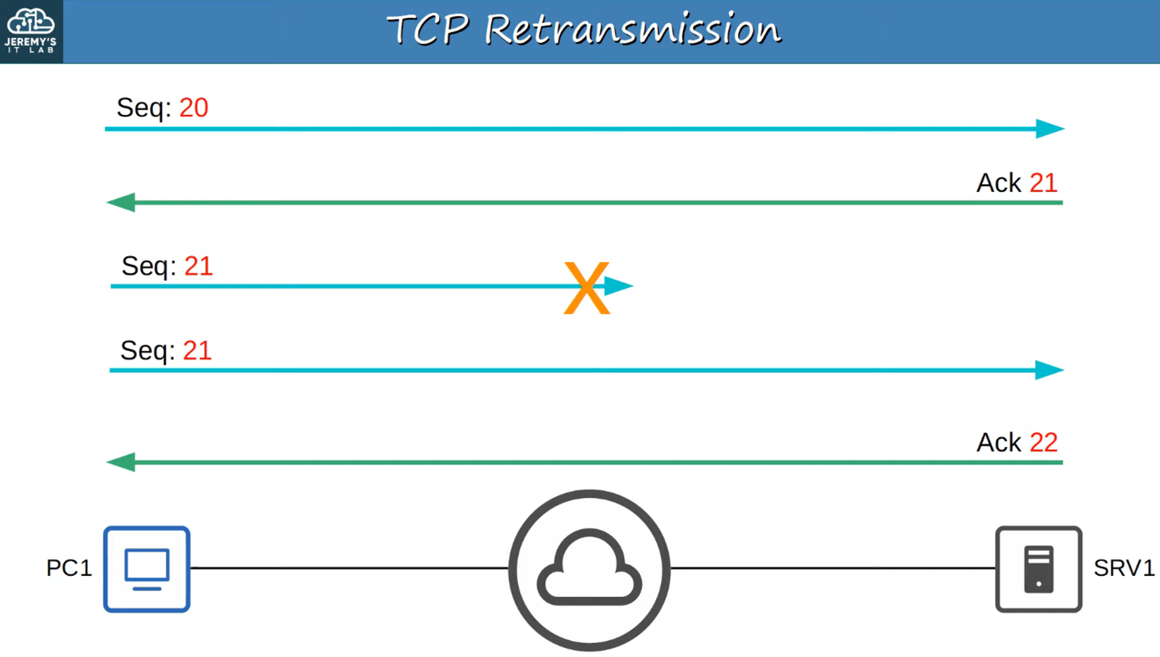
* **Sequencing**:  
  + Sequence numbers in the TCP header allow hosts to reorder segments correctly.  
     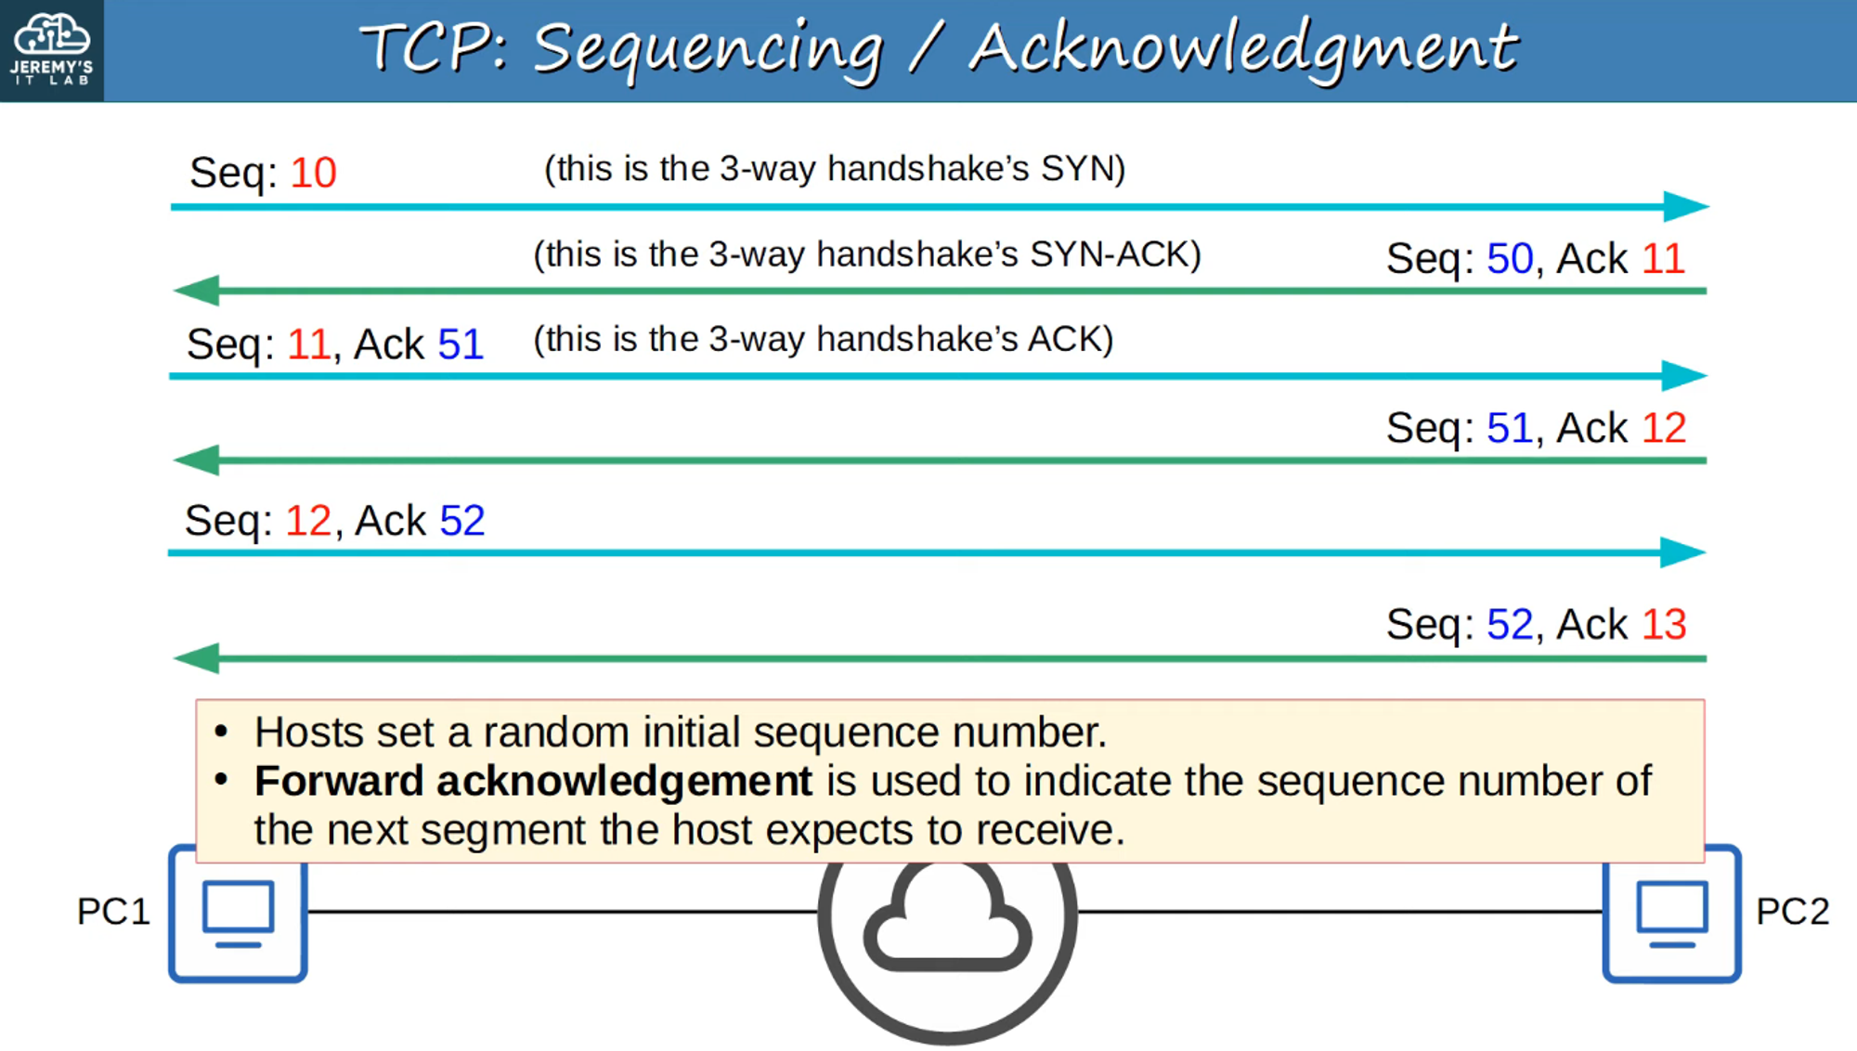
* **Flow Control**:  
  + Destination host can regulate the rate at which data is sent.  
     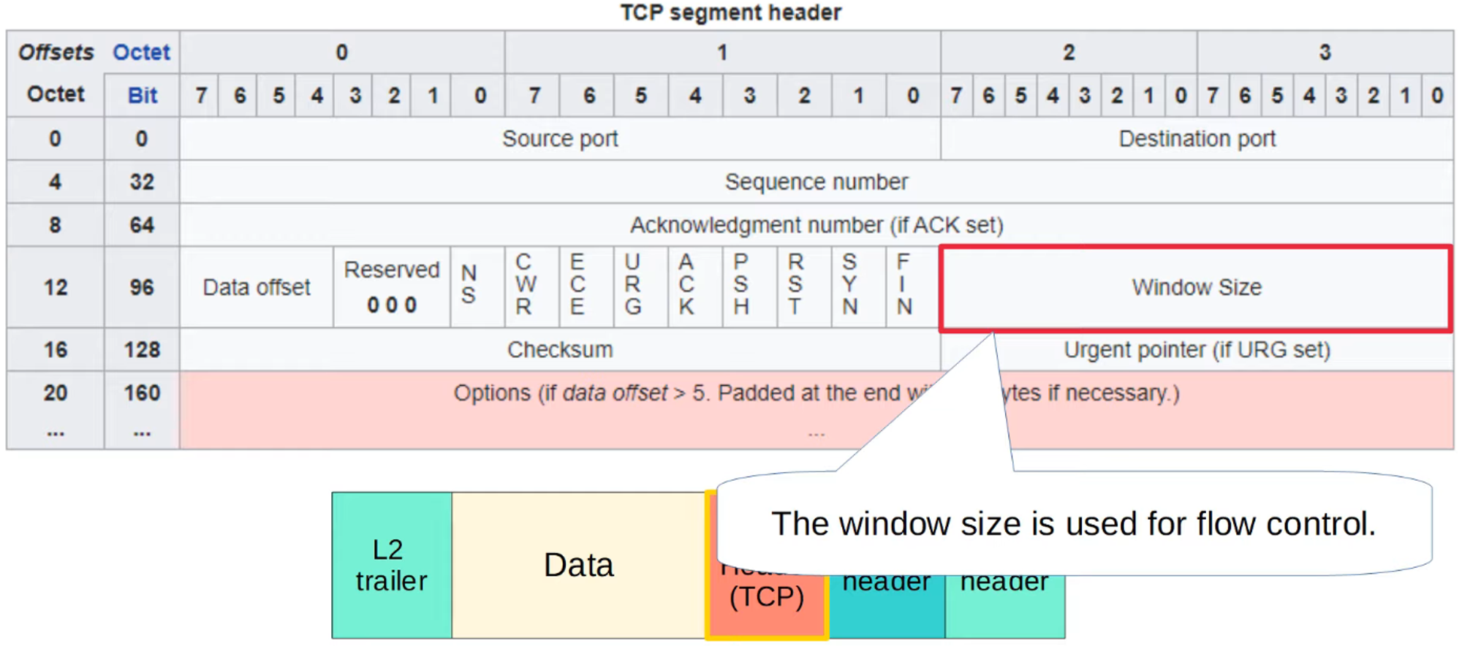  
     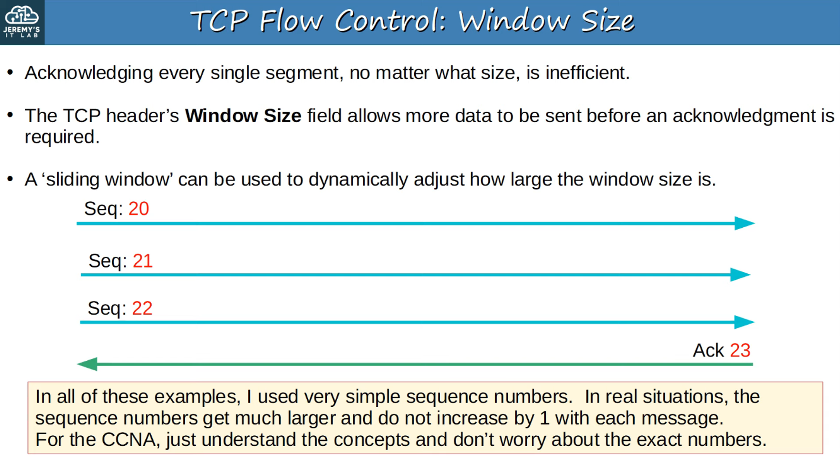

## **UDP (User Datagram Protocol)**

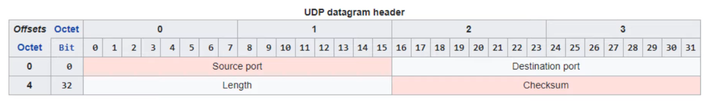

* **Not Connection-Oriented**:  
  + Data is sent without establishing a connection.
* **Unreliable Communication**:  
  + No acknowledgments for received segments.
  + Lost segments are not retransmitted.
* **No Sequencing**:  
  + Segments arriving out of order cannot be reassembled.
* **No Flow Control**:  
  + Unlike TCP, UDP doesn’t regulate data flow.
* **Error Checking**:  
  + UDP provides error-checking via checksum.

## **Comparing TCP and UDP**

### **Number of Fields in Their Headers:**

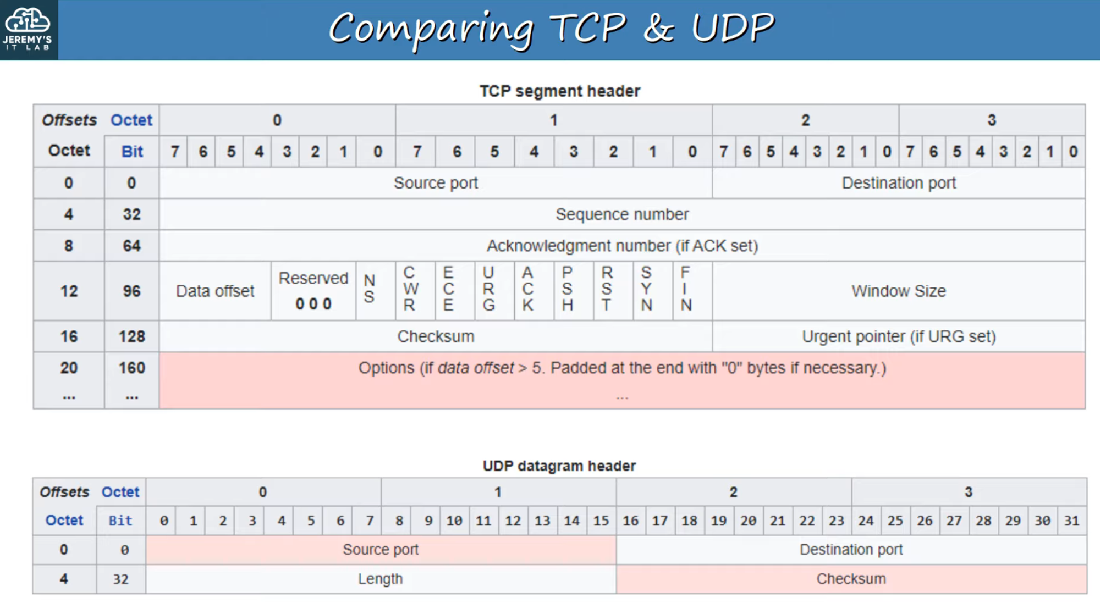

**Here’s the formatted version:**

### **TCP vs. UDP Features and Use Cases**

* **TCP provides more features than UDP but at the cost of additional overhead.**
  + **TCP is preferred for applications requiring reliable communication (e.g., downloading files).**
  + **UDP is preferred for real-time voice and video applications.**
  + **Some applications use UDP but implement reliability features within the application itself.**
  + **There are also applications that use both TCP and UDP, depending on the situation.**

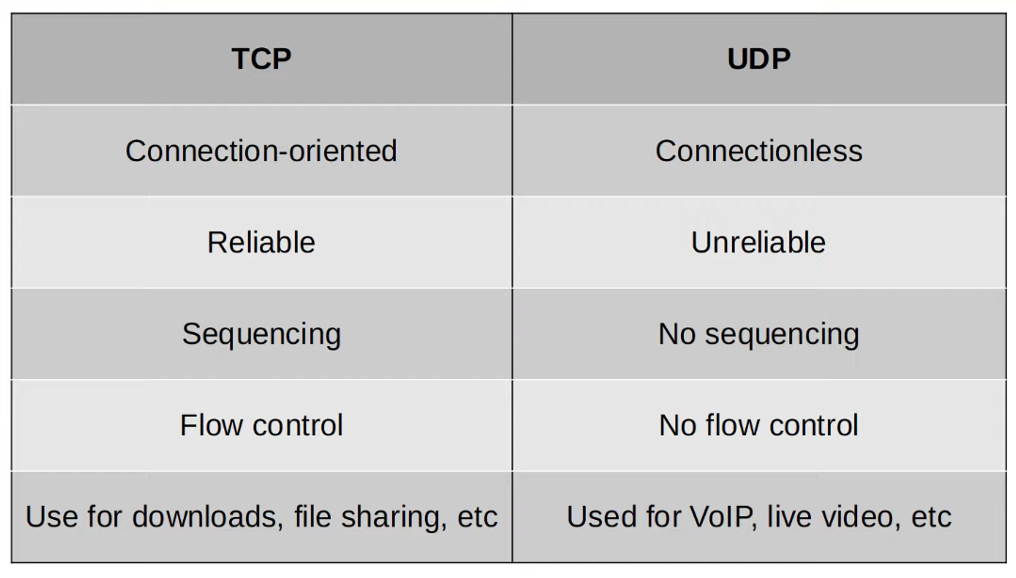

### **Important Port Numbers**

